
School: Sonalika Samal Campus: BBSR Academic Year: 2024-2026
Subject Name: ........................................................... Subject Code: ..........................
Semester: ............... Program: ........................................ Branch: ......................... Specialization: .......................... Date: .....................................
(Learning by Doing and Discovery)
* Coding Phase: Pseudo Code / Flow Chart / Algorithm
MetaMask – Gateway to Web3
Ethereum and other public blockchains are like open, shared databases for the internet’s future. MetaMask acts as your personal access tool to this new digital world.
Available as both a mobile app and browser extension, MetaMask lets you:
- Store and manage tokens such as Ether
- Secure your Ethereum and Solana private keys
- Connect easily to decentralized applications (dApps)
MetaMask never keeps your personal information or private keys you alone control your blockchain identity.

Installing MetaMask
1. Download and Install
- Visit the official MetaMask website to avoid fake copies.
- Choose your browser and download the correct extension.
- Add the extension by following the on-screen instructions until it appears in your browser’s toolbar.
2. Set Up a New Wallet
- Launch MetaMask and click “Get Started.”
- Choose “Create a Wallet.”
- Create a secure password and confirm it.
- MetaMask will show a 12-word Secret Recovery Phrase — write it on paper and keep it offline in a safe place.
- Verify the phrase by selecting the words in the correct sequence.
- Your wallet is now active.
3. Access and Use
- Click the fox icon to open MetaMask anytime.
- Click your account name to copy your public wallet address and share it when receiving funds.

Coding Phase: Pseudo Code / Flow Chart / Algorithm

* Software used
- Brave Browser
- MetaMask

- Testing Phase: Compilation of Code (error detection)
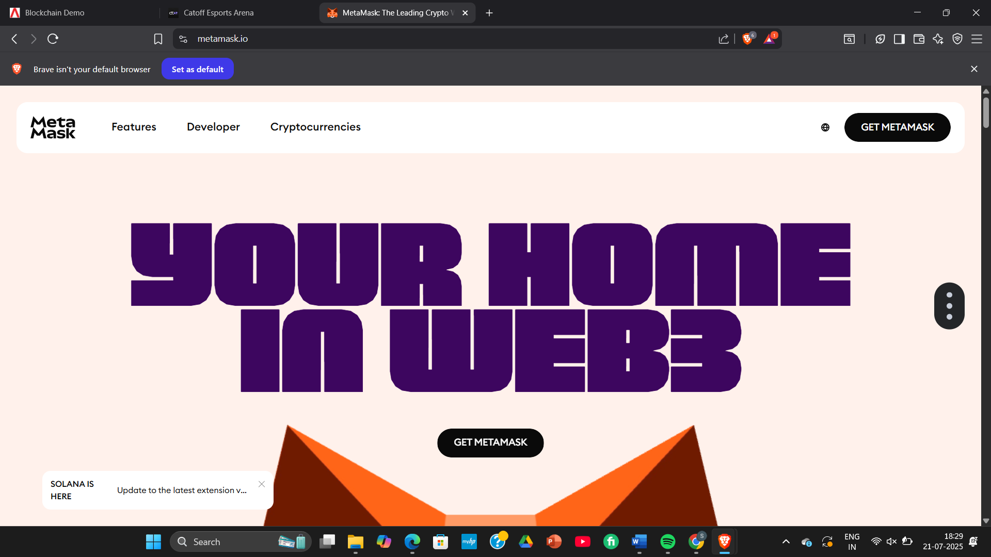

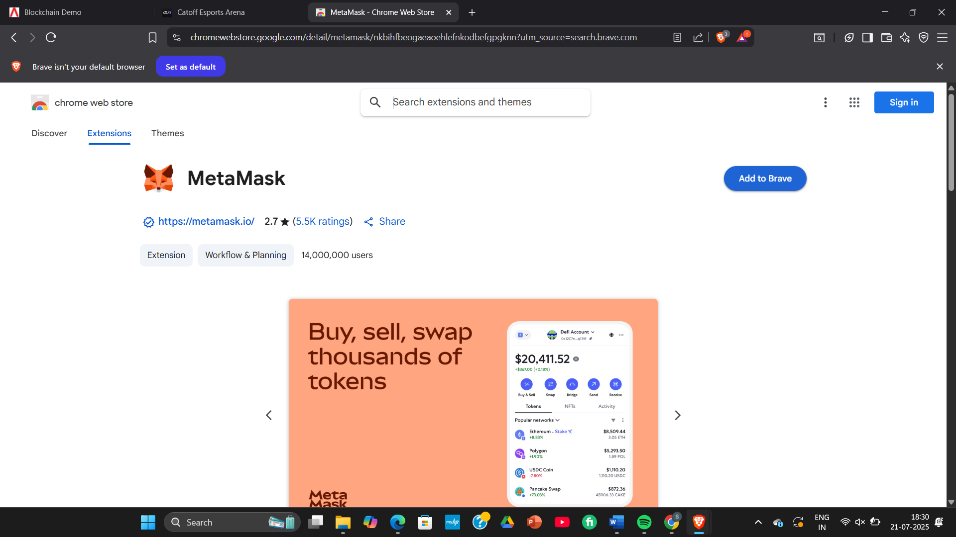
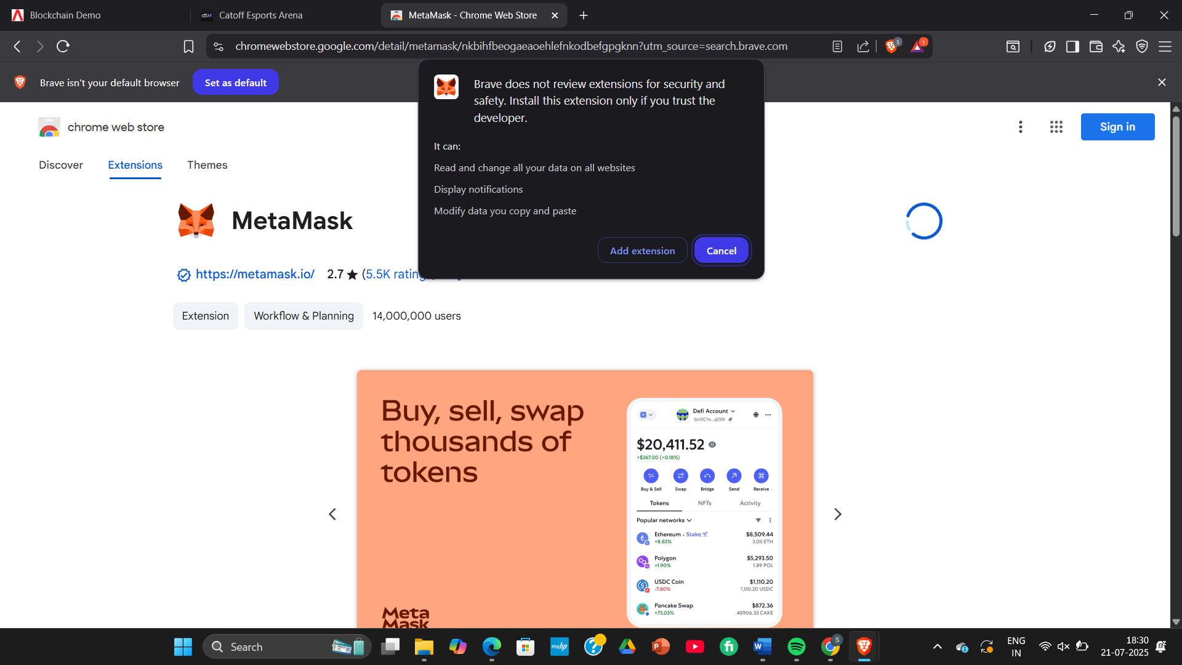

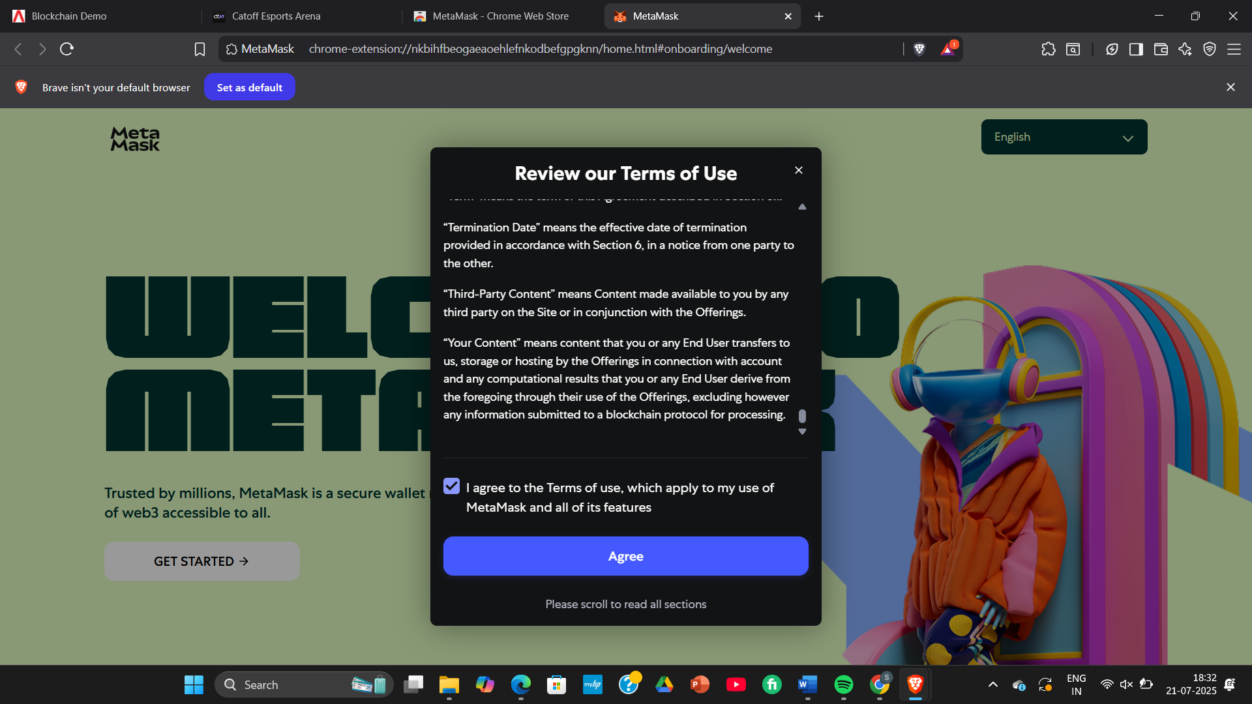
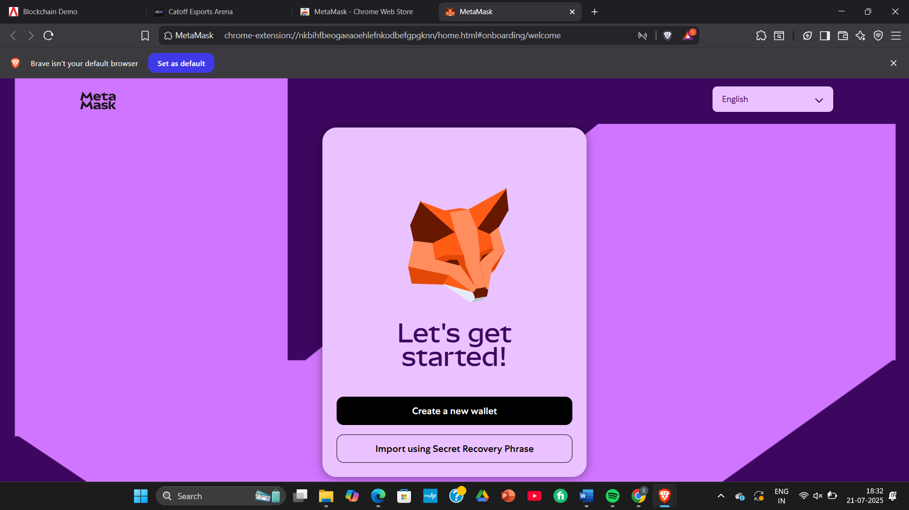

- Testing Phase: detection of Code (error detection)
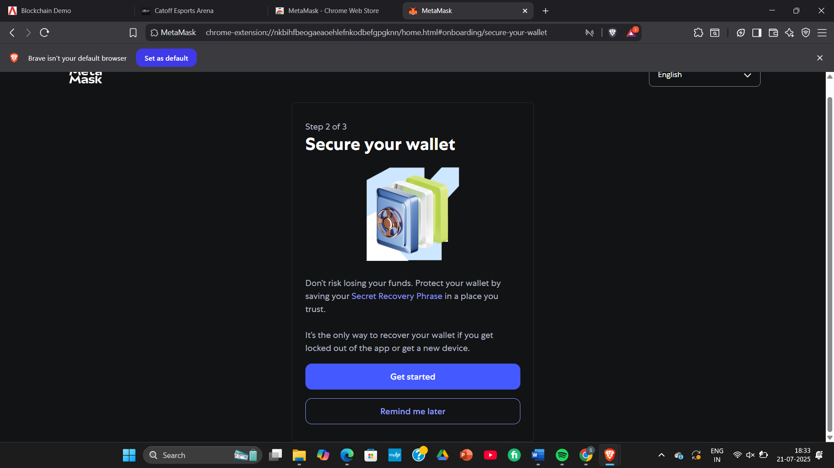

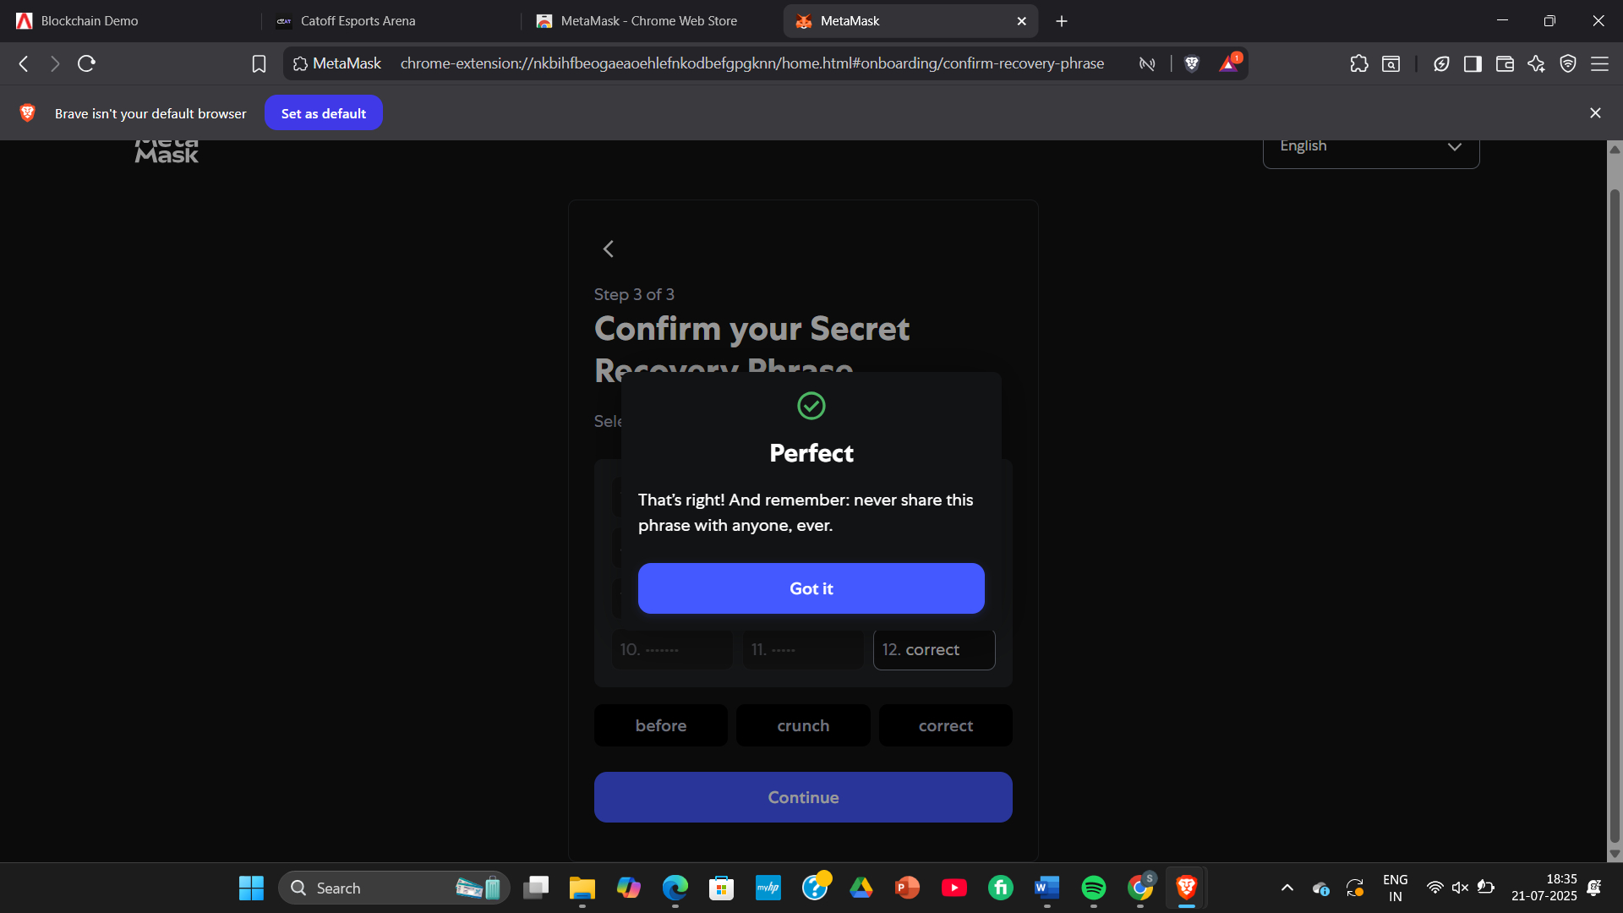

Implementation Phase: Final Output (no error)
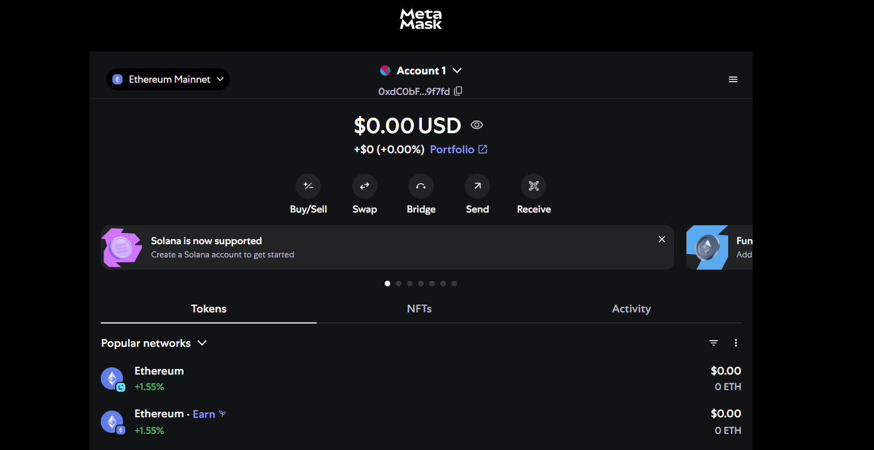

- Implementation Phase: Final Output (no error)
Applied and Action Learning

* Observations
- The recovery phrase works like a master password that unlocks your entire wallet.
- A password can protect access on your device, but it’s not a replacement for backing up your recovery phrase.
- Every wallet contains a public address (used for receiving funds) and a private key (used to authorize transactions).
- You can share your public address openly, but your private key must remain confidential.
- A wallet doesn’t hold cryptocurrency itself — it stores the credentials needed to access your assets on the blockchain.
- MetaMask functions as both a private key vault and a tool to approve transactions.
- The network you choose controls which blockchain data your wallet displays.

ASSESMENT

Rubrics
Concept | 10
Planning and Execution/  Practical Simulation/ Programming | 10
Result and Interpretation | 10
Record of Applied and Action Learning | 10
Viva | 10
Total | 50


Signature of the Student:
Signature of the Faculty:

